|  |  |  |
| --- | --- | --- |
|  | **JSPMs**  **JAYAWANTRAO SAWANT POLYTECHNIC, Handewadi Road, Hadapsar, Pune-28**  **Department of Computer Engineering**  **Academic Year 2022-23** | **logo** |

**MICRO PROJECT**

**After studying Standard English Newspaper, prepare booklet identifying various grammatical aspects of sentences.**

-----------------------------------------------------

**Program:** CO **Program code:** CO1I

**Course:** English **Course code:** 22101

**Class:** FYCO1 **Group No: 2**

**Project Guide:** Mrs.Thorat S.N.



**MAHARASHTRA STATE BOARD OF TECHNICAL EDUCATION**

**Certificate**

This is to certify that Mr. / Ms. ------------------------------------------------------------------------------------------------------------------------------------------------------------------------------------------------of I Semester of Diploma in Computer Engineering of Institute Jayawantrao Sawant Polytechnic (Code: 0711) has completed the Micro Project satisfactorily in Subject – English (22101) for the academic year 2022-23 as prescribed in the curriculum.

Place: Hadapsar, Pune. Enrollment No: -------------------------

--------------------------------------------

--------------------------------------------

Date: …… Exam Seat No: -------------------------

--------------------------------------------

--------------------------------------------

Subject Teacher Head of the Department Principal

**MICRO PROJECT**

**GROUP DETAILS**

|  |  |  |  |  |
| --- | --- | --- | --- | --- |
| **Sr No.** | **Roll No.** | **Name** | **Enrolment No.** | **Seat No.** |
| 1 | 28 | Pawar Sarthak Baban | 2207110398 | 179986 |
| 2 |  |  |  |  |
| 3 |  |  |  |  |
| 4 |  |  |  |  |
| 5 |  |  |  |  |
| 6 |  |  |  |  |
| 7 |  |  |  |  |
| 8 |  |  |  |  |
| 9 |  |  |  |  |
| 10 |  |  |  |  |

**INDEX**

|  |  |  |
| --- | --- | --- |
| **Sr No.** | **Content** | **Page No.** |
| 1 | Certificate | 2 |
| 2 | Group Details | 3 |
| 3 | Index | 4 |
| 4 | Annexure IA (part A) | 5 |
| 5 | Cover Page of Booklet | 6 |
| 6 | Article | 7 |
| 7 | Grammatical Aspects of Heading and Subheading | 8 |
| 8 | Grammatical Aspects of Article - Nouns | 9 |
| 9 | Grammatical Aspects of Article – Pronoun, Adjectives, Verbs | 10 |
| 10 | Grammatical Aspects of Article – Adverb, Prepositions, Conjunctions, Interjections | 11 |
| 11 | Annexure II A (Part B) | 12 |
| 12 | Annexure III (Teachers Evaluation Sheet) | 13 |
| 13 | Annexure IV Micro Project Evaluation Sheet | 14 |

|  |  |  |
| --- | --- | --- |
|  | **JSPMs**  **JAYAWANTRAO SAWANT POLYTECHNIC, Handewadi Road, Hadapsar, Pune-28**  **Department of Computer Engineering**  **Academic Year 2022-23** | **logo** |

**Title: After studying Standard English Newspaper, prepare booklet identifying various grammatical aspects of sentences.**

1. **Brief Introduction:**

**------------------------------------------------------------------------------------------------------------------------------------------------------------------------------------------------------------------------------------------------------------------------------------------------------------------------------------------------------------------------------------------------------------------------------------------------------------------------------------------------------------------------------------------------------------------------------------------**

1. **Aim of Micro Project:**

**------------------------------------------------------------------------------------------------------------------------------------------------------------------------------------------------------------------------------------------------------------------------------------------------------------------------------------------------------------------------------------------------------------------------------------------------------------------------------------------------------------------------------------------------------------------------------------------**

**3.0** **Action Plan** (Sequence and time required for major activities for 8 week)

|  |  |  |  |  |
| --- | --- | --- | --- | --- |
| **Sr. No** | **Details of activity** | **Planned start date** | **Planned Finish date** | **Name of Responsible Team members** |
| 1 | Collecting the information of view |  |  |  |
| 2 | Sorting the information of view |  |  |
| 3 | Compilation of the project |  |  |
| 4 | Submission of the project |  |  |

**4.0 Resources required** (major resources such as raw material, some machining facility, software etc.)

|  |  |  |  |  |
| --- | --- | --- | --- | --- |
| **Sr. NO** | **Name of resource / material** | **Specification** | **Quantity** | **Remarks** |
| 1 |  |  |  |  |
| 2 |  |  |  |  |
| 3 |  |  |  |  |

Grammatical Aspects

of Sentences



News Article

Source: Hindustan Times

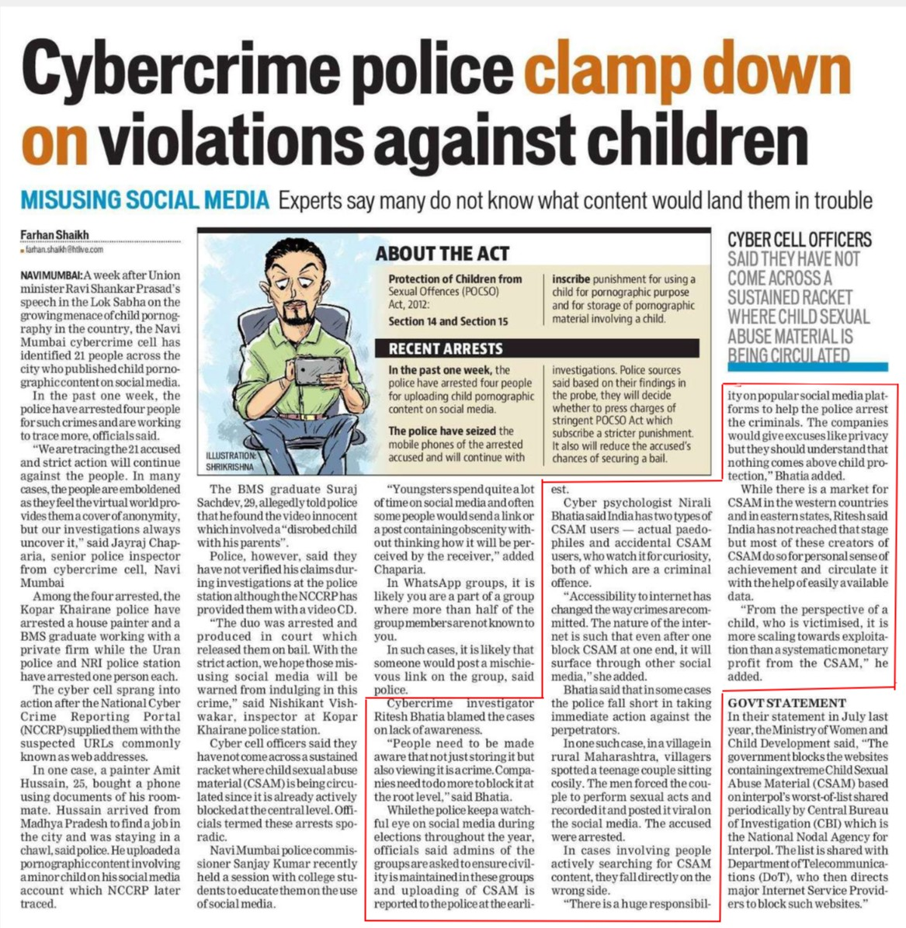

Grammatical Aspects

of Heading



Preposition Noun

Noun Verb Adverb

Noun Preposition

of Sub-Heading



Noun Pronoun

Verb Adjective Verb Verb Modal Verb Noun

Noun Pronoun Noun Preposition

Pronoun

Adverb Noun

Grammatical Aspects

of Article

_______________________________________________

Nouns:

Cybercrime, Police, Violations, Children, MISUSING, SOCIAL, MEDIA, Experts, Content, Trouble, Farhan, Shaikh, Farhan Shaikh, @, Htlive.Com, NAVIMUMBAI, Week, Union, Minister, Ravi, Shankar, Prasad, Speech, Lok Sabha, Menace, Child, Pornography, Country, Navi Mumbai, Cybercrime, Cell, People, City, Content, Media, Week, Police, People, Crimes, Officials, Action, People, Cases, People, World, Pro-, Vides, Cover, Anonymity, Investigations, Jayraj, Chap-, Aria, Police, Inspector, Cybercrime, Cell, Navi, Mumbai, Kopar, Khairane, Police, House, Painter, BMS, Graduate, Firm, Uran, Police, NRI, Police, Station, Person, Cyber, Cell, Sprang, Action, National, Cyber, Crime, Reporting, Portal, NCCRP, Urls, Web, Addresses, Case, Painter, Amit, Hussain, Phone, Documents, Mate, Hussain, Madhya, Pradesh, Job, City, Chawl, Police, Content, Child, Media, NCCRP, ILLUSTRATION, SHRIKRISHNA, BMS, Graduate, Suraj, Sachdev, Police, Video, Innocent, Child, Parents, Police, Claims, Investigations, Police, Station, NCCRP, CD, Duo, Court, Bail, Action, Media, Crime, Nishikant, Wakar, Inspector, Kopar, Khairane, Police, Station, Cyber, Cell, Officers, Racket, Child, Abuse, Material, CSAM, Level, Navi Mumbai, Police, Sanjay, Kumar, Session, College, Dents, Media, Protection, Children, Offences, POCSO Act, , Section, RECENT, ARRESTS, Week, Police, People, Content, Media, Police, Phones, Youngsters, Lot, Time, Media, People, Link, Post, Obscenity, With-, Receiver, Chaparia, Whatsapp, Groups, Part, Group, Half, Group, Members, Cases, Someone, Link, Group, Police, Cybercrime, Investigator, Ritesh, Bhatia, Cases, Lack, Awareness, People, Root, Level, Bhatia, Police, Eye, Media, Elections, Year, Officials, Admins, Groups, Groups, CSAM, Police, Punishment, Child, Purpose, Storage, Material, Child, Investigations, Police, Sources, Findings, Probe, Charges, POCSO Act, Punishment, Accused, Chances, Bail, Cyber, Nirali, Bhatia, India, Types, CSAM, Files, CSAM, Users, Curiosity, Offence, Accessibility, Way, Crimes, Nature, Net, Block, CSAM, End, Media, Bhatia, Cases, Police, Fall, Action, Case, Maharashtra, Villagers, Couple, Men, Ple, Acts, Media, CYBER, CELL, OFFICERS, SAID, THEY, HAVE, NOT, COME, ACROSS, A, SUSTAINED, RACKET, WHERE, CHILD, MATERIAL, IS, BEING, CIRCULATED, Media, Forms, Police, Criminals, Companies, Excuses, Privacy, Nothing, Child, Section, Bhatia, Market, CSAM, Countries, States, Ritesh, India, Stage, Creators, CSAM, Sense, Achievement, Help, Data, Perspective, Child, Towards, Profit, CSAM, GOVT, Statement, July, Year, Ministry, Women, Child, Development, Government, Websites, Child, Material, CSAM, Central, Bureau, Investigation, CBI, National, Nodal, Agency, Cases, People, Interpol, List, CSAM, Department, Telecommunica-, Content, Tions, Dot, Side, Internet, Service, Websites

Pronouns:

What, Them, Who, We, They, Them, Our, It, Them, His, He, His, He, His, They, His, Them, Them, We, They, It, Them, It, It, You, You, It, It, It, It, Their, They, It, Who, It, It, She, It, It, They, It, Who, It, He, Their, They, Who.

Adjectives:

Many, Child, Pornographic, Social, Past, Such, More, Strict, Many, Virtual, Senior, Private, Suspected, Room, Pornographic, Minor, Social, Disrobed, Video, Strict, Social, Sexual, Central, Official, Social, Past, Child, Pornographic, Social, Mobile, Social, Per-, Likely, More, Such, Likely, Aware, More, Watch-, Full, Social, Civil, Early, Inscribe, Pornographic, Pornographic, Stringent, Stricter, Psychologist, Accidental, Criminal, Inter, Such, Other, Social, Short, Immediate, Such, Rural, Teenage, Sexual, Viral, Social, Popular, Social, Plat-, Pro-, Western, Eastern, Most, Personal, Available, Scaling, Systematic, Monetary, Last, Extreme, Worst-Of-List, Wrong, Major, Huge, Such.

Verbs:

Clamp, Say, Do, Know, Would, Land, Growing, Has, Identified, Published, Have, Arrested, Are, Working, Trace, Said, Accused, Will, Continue, Are, Emboldened, Feel, Said, Arrested, Have, Arrested, Working, Have, Arrested, Supplied, Known, Bought, Using, Arrived, Find, Was, Staying, Said, Uploaded, Involving, Account, Traced, Told, Found, Involved, Said, Have, Verified, Has, Provided, Was, Arrested, Produced, Released, Hope, Using, Will, Be, Warned, Indulging, Said, Said, Come, Sustained, Is, Being, Late, Is, Blocked, Termed, Held, Educate, Have, Arrested, Uploading, Have, Seized, Arrested, Accused, Will, Continue, Spend, Would, Send, Containing, Thinking, Will, Be, Ceiled, Added, Is, Are, Are Not, Known, Is, Would, Post, Said, Blamed, Need, Be, Made, Storing, Viewing, Is, Need, Block, Said, Keep, Said, Are, Asked, Ensure, Is, Maintained, Is, Reported, Using, Involving, Said, Based, Will, Decide, Press, Subscribe, Will, Reduce, Securing, Said, Has, Watch, Are, Internet, Has, Changed, Are, Mitted, Is, Will, Surface, Added, Said, Taking, Spotted, Sitting, Forced, Perform, Recorded, Posted, Accused, Were, Arrested, Help, Arrest, Would, Give, Should, Understand, Comes, Added, Is, Said, Has, Reached, Do, Circulate, Is, Victimized, Is, Added, Said, Blocks, Containing, Based, Shared, Is, Involving, Is, Shared, Searching, Fall, Directs, Is, Block.

Adverbs:

down, not, always, commonly, later, allegedly, however, not, where, already, actively, recently, quite, often, how, where, not, just, also, also, even, not, so, easily, more, periodically, actively, directly, then

Prepositions:

On, Against, In, After, In, On, Of, In, Across, On, In, For, Against, In, As, Of, Uncover, From, Among, With, While, Into, After, With, As, In, Of, From, In, In, On, That, With, At, Although, With, In, On, With, From, In, At, Across, Since, At, With, On, Of, ABOUT, Of, From, In, For, On, Of, With, Of, On, Out, By, In, Of, Than, Of, In, That, On, On, Of, That, At, While, On, During, Throughout, Of, In, Of, At, For, For, For, Of, On, In, Whether, Of, Of, Of, For, Of, Of, That, After, At, Through, That, In, In, Against, In, In, On, On, Like, That, Above, While, For, In, In, That, Of, Of, For, Of, With, Of, From, Of, Than, From, In, In, Of, On, By, Of, For, In, With, For, Of

Conjunctions:

And, But, Or.

Interjection:

-

|  |  |  |
| --- | --- | --- |
|  | **JSPMs**  **JAYAWANTRAO SAWANT POLYTECHNIC, Handewadi Road, Hadapsar, Pune-28**  **Department of Computer Engineering**  **Academic Year 2022-23** | **logo** |

**After studying Standard English Newspaper, prepare booklet identifying various grammatical aspects of sentences.**

**1.0 Brief Description:**

**-----------------------------------------------------------------------------------------------------------------------------------------------------------------------------------------------------------------------------------------------------------------------------------------------------------------------------------------------------------------------------------------------------------------------------------------------------------------------------------------2.0 Aim of Micro Project:**

**-------------------------------------------------------------------------------------------------------------------------------------------------------------------------------------------------------------------------------------------------------------------------------------------------------------------------------------------------------------------------------------------------------------------------------------------------------------------------------------------**

**3.0 Course Outcome Integrated**

----------------------------------------------------------------------------------------------------------------------

**4.0 Actual Procedure Followed.**

1. ---------------------------------------------------------------------------------------------------------------

2.----------------------------------------------------------------------------------------------------------------

3.----------------------------------------------------------------------------------------------------------------

**5.0 Actual Resources Used** (mention the actual resources used.)

|  |  |  |  |  |
| --- | --- | --- | --- | --- |
| **Sr. NO** | **Name of resource / material** | **Specification** | **Quantity** | **Remarks** |
| 1 |  |  |  |  |
| 2 |  |  |  |  |
| 3 |  |  |  |  |

**6.0 Outputs of the Micro Projects**

---------------------------------------------------------------------------------------------------------------------------------------------------------------------------------------------------------------------------------------------

**7.0 Skill Developed/ Learning out of this Micro project**

Throughout this project we developed some important skills like leadership quality, scheduling of the project and risk management. One of the most important skills we developed is the communication and coordination between our team members. We also learned planning skills, time management and adaptability.

**Teacher Evaluation Sheet**

**Name of students:**

**Enrollment No**:

**Name of programme :** Computer Engineering

**Semester**: Ist

**Course Title**: English

**Code:** 22101

**Title of Micro Project:** After studying Standard English Newspaper, prepare booklet identifying various grammatical aspects of sentences.

**Course Outcomes Achieved:**

**Evaluation as per suggested Rubric for Assessment of Micro Project**

|  |  |  |  |  |  |
| --- | --- | --- | --- | --- | --- |
| **Sr. No** | **Characteristic to be assessed** | **Poor**  (Marks1- 3) | **Average**  (Marks 4 -5) | **Good**  (Marks 6 -8) | **Excellent**  (Marks 9 - 10) |
| 1 | Relevance to the course |  |  |  |  |
| 2 | Literature Survey / Information collection |  |  |  |  |
| 3 | Project Proposal |  |  |  |  |
| 4 | Completion of the Target as per Project Proposal |  |  |  |  |
| 5 | Analysis of data and representation |  |  |  |  |
| 6 | Quality of Prototype/ Model |  |  |  |  |
| 7 | Report preparation |  |  |  |  |
| 8 | Presentation |  |  |  |  |
| 9 | Defense |  |  |  |  |

**Micro Project Evaluation Sheet**

|  |  |  |  |  |
| --- | --- | --- | --- | --- |
| **Process Assessment** | | **Product Assessment** | | **Total Marks**  **10** |
| **Part A - Project Proposal**  **(2 Marks)** | **Project Methodology**  **(2 Marks)** | **Par B - Project Report/ working Model**  **(2 Marks)** | **Individual Presentation/ Viva**  **(4 Marks)** |
|  |  |  |  |  |

**Note: Every course teacher is expected to assign marks for group evaluation in first 3 columns and individual evaluation 4th column**

**Comment/ suggestion about team work/leadership/ interpersonal communication (If any)**

………………………………………………………………………………………………………………………………………………………………………………………………………………………………………………………………………………………………………………………………………………………………………………………………………………………………………………………………………

………………………………………………………………………………………………………………………………………………………

**Any other comment:**

………………………………………………………………………………………………………………………………………………………………………………………………………………………………………………………………………………………………………………………………………………………………………………………………………………………………………………………………………

**Name and Designation of the Faculty Member: Mrs.Thorat S.N.**

**Signature: ………………………….**